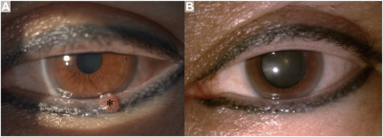

On examination, a 2 *2-mm pink peduncular mass was observed on the left lower lid (A, asterisk). Nohistory of papilloma, human papillomavirus infection vaccination (HPV), or eye injury was reported. The patient declined treatment forpapilloma, including oral medications. She subsequently obtained the HPV 9-valent vaccine on her own accord, and after 2 doses ofvaccine, (B) the pink mass resolved within 2 months. Based on the provided images and clinical description please make an ophthalmic diagnosis for this patient. And output the diagnostic conclusions only.

**Eyelid papilloma**